TABLE OF CONTENTS
I. Overview
Welcome Letter ...................................................................................... Page 2
About Have A Gay Day ............................................................................ Page 3
II. Volunteerism
Types ...................................................................................................... Page 4
Requirements ......................................................................................... Page 4
Responsibilities ....................................................................................... Page 4
Volunteers Guidelines ............................................................................. Page 4
III. Volunteer Documents
ETHICAL STANDARDS ................................................................................Page 7
POLICY ACKNOWLEDGEMENT/AGREEMENT ........................................... Page 9
CONFIDENTIALITY AGREEMENT ................................................................Page 12
VOLUNTEER SIGNATURE PAGE .................................................................Page 13
IV. Addendum for in-person volunteers
Instructions and guidelines for recurring events ..................................... Page 14
Food Pantry Prep ........................................................................ Page 14
Food Pantry Sunday .....................................................................Page 16
Miami Valley Meals Pickup ..........................................................Page 20
Food Bank Delivery.......................................................................Page 21
V. Addendum for online volunteers
Digital Team Guidelines and Instructions .................................................Page 22
Welcome .....................................................................................Page 22
Overview .....................................................................................Page 23
Breakdown of positions ..............................................................Page 25
Rules ...........................................................................................Page 27

Welcome Letter
To the volunteers of Have A Gay Day,
Welcome to Have A Gay Day! As a volunteer, you will be providing an invaluable resource to both the organization and the LGBT community. We have been through a lot as an organization since our Facebook "Meta" was created on February 25, 2012. This platform, our in-person location, and all of our other platforms constantly are changing as the world changes and our technology and interactions change. We may not always be aware of all the changes in our community such as terminology, experiences, or politics. However, we will do our best to be professional and kind to each member of our community that we interact with.
This space is not simply a safe space but a brave space. There may be moments that cause distress that you will encounter in-person, on the page, and in the messages of "Meta" and our other social channels. We remind you that your physical and mental health always comes first, whether at an in-person volunteering event or when online dealing with difficult topics, ignorance, trolls, and hate. We also remind you that your impact on the community and page is vital for all the members of the community. Don't ever feel that a response or message or comment has to be decided by you. As much as we are here for our community, we are here for each other.
We also remind you that you are not just representing yourself in your volunteer work, you are also representing Have A Gay Day. Your interactions directly impact the whole volunteer team and the organization. We are honored that you have chosen to volunteer with us and hope that your experience with us continually improves and strengthens.
Thank you again for everything. If you ever have any questions, concerns, or comments, please feel free to reach out to myself or any member of the board or the Digital Team of Have A Gay Day at any time. Our contact info is on our website and any admin of our groups.
Michael Knote
Have A Gay Day

About Have A Gay Day
Welcome to Have A Gay Day:
The mission of Have A Gay Day is to create a safe environment for the purpose of equality, education, and support for the LGBTQ+ community and their allies.
Volunteerism at Have A Gay Day:
Have A Gay Day takes great pride in its volunteers. Through your efforts, we are better able to meet our community's needs and challenges. It is our goal to provide a positive and rewarding volunteer experience for you while also supplying much needed support to Have A Gay Day and our extended community.
On the following pages, you will find a handbook designed specifically for you as part of your orientation. This handbook provides guidelines for volunteering with Have A Gay Day.
We are excited to have you as a member of the team and hope you will find your experience with us challenging, rewarding, and worthwhile.
If you have any further questions, contact the designated volunteer coordinator.

Volunteerism
TYPES
Have A Gay Day provides multiple avenues to get involved as a volunteer. This includes:
- In-person volunteering for regularly scheduled events (Pantry Prep Days, Miami Valley Meal pickup, Food Bank delivery, Food Pantry Sunday) and special events (Pride events, LGBTQ+ networking events, etc.).
- Online volunteerism, such as becoming a page moderator or assisting in outreach.
REQUIREMENTS
To volunteer with Have A Gay Day, potential volunteers must sign up via the Point app and complete and submit the following volunteer documents:
- Volunteer application
- Volunteer handbook
- Ethical Standards
- Policy acknowledgment and agreement
VOLUNTEER GUIDELINES
Volunteer assignments:
- If you are ever experiencing any problems or issues with a volunteer assignment, please let the volunteer coordinator know as soon as possible. If you need to cancel a shift, please cancel via the Point app.
- All volunteer documents related to volunteering at Have A Gay Day must be completed and submitted prior to the start of the first volunteer assignment.
Attendance and punctuality:
- Please contact Michael or the volunteer coordinator if you are running late or not coming – this helps us plan and adjust. If you are unable to make it, please cancel on the Point app.
Professionalism:
- Greet guests and clients and welcome them to Have A Gay Day.
- If you don't recognize a client, ask: "Hi, welcome to Have A Gay Day. How can we help you?"
- Assist clients by assessing what they might need, collecting information from them, and providing information about the resources available which might best suit their needs.
- Use the Resource Guide to point clients and visitors in the right direction.
- When you don't know an answer it's okay to say: "I don't know, let me find out for you." Find another volunteer to assist you or take down the client's information to contact them when we have accurate information.
- Avoid assumptions about someone's identity. This includes gender, so refrain from using pronouns such as him/her/them/Sir/Mrs./Ms. unless a client and/or guest specifically states this is how they want to be referenced.
- In addition, our guests, clients, and community members visit us from all walks of life and experiences. It is important for them to feel welcome and comfortable being exactly who they are in a non-judgmental space.
Confidentiality:
- Volunteers are required to maintain confidentiality of privileged information shared during volunteer shifts. Confidentiality should be maintained both during and outside of volunteer shifts.
Media/Press Relations:
- Volunteers are not authorized to give out new releases, press releases, or speak to the press or media on behalf of Have A Gay Day. Please refer all media/press relations requests to a staff member on duty.
Computer usage:
- Personal use of computers and the internet is permitted depending on volunteer assignment.
- Have A Gay Day does not allow employees or volunteers to view content which is considered lewd, indecent, pornographic, or offensive. If there are concerns that content which falls under these guidelines is being viewed, contact the volunteer coordinator.
- Failure to comply with the Have A Gay Day computer usage policy will be considered grounds for termination of a volunteer's assignment.
Discrimination/Harassment:
- It is the policy of Have A Gay Day to be free from all forms of discrimination, including sexual harassment (unwelcomed sexual advances, requests for sexual favors, and other verbal or physical conduct of a sexual nature). Please immediately report any discrimination or perceived discrimination to the volunteer coordinator and/or executive director.
Dress code:
- Know dress code requirements before volunteering. If there a no specific uniform guidelines for the assignment, maintain a professional appearance.
Alcohol and Drug use:
- Have A Gay Day is a drug-free workplace. This means volunteers shall not consume alcohol and/or drugs, be under the influence of alcohol and/or drugs, or possess an open container of alcohol, or unlawfully manufacture, distribute, dispense, possess, or use illegal drugs while representing Have A Gay Day in any capacity or role. Volunteers found in violation of this policy will be immediately terminated as a volunteer with Have A Gay Day.
Threats and Violence in the Workplace:
- Have A Gay Day is committed to providing a safe work environment that is free of violence or the threat of violence. Threats, threatening behavior, or acts of violence against volunteers, employees, visitors, or other individuals by anyone on the Have A Gay Day property will not be tolerated.
- Volunteers are expected to follow the same policies and procedures as employees regarding threats and violence in the workplace.
- Have A Gay Day maintains a zero-tolerance policy regarding violence in the workplace. This means threats/acts of violence will not be permitted. Any volunteers found threatening violence or perpetuating violence against any Have A Gay Day employee, volunteer, client, or other individual on Have A Gay Day premises will be immediately terminated as a volunteer with Have A Gay Day.
Reimbursement:
- Prior approval is required by the volunteer coordinator before making any purchases that may be intended for reimbursement by Have A Gay Day.
- Purchases made without prior approval will not be reimbursed.

VOLUNTEER DOCUMENT:
ETHICAL STANDARDS
(FORM A)
The purpose of these standards is to guide employees, consultants and volunteers in better assisting clients, families, and our community. They are meant to encourage volunteers' already established working knowledge of profession standards as a volunteer with Have A Gay Day and the Have A Gay Day.
These standards address situations where professional relationships of unequal power exist, such as with a service provider and service recipient and a supervisor and line staff. These standards are not intended to be an exhaustive list; they simply address those situations which most frequently arise. There will always be gray areas. It is then that you must utilize your best judgment. Seeking additional support from either your supervisor or the Administrative or Executive Director is encouraged in order to provide a safe, ethical, professional, and fair environment for everyone. It is not the intent of these ethical standards to prohibit the natural development of relationships between and among staff and volunteers, but rather to provide a set of guidelines that will make it possible for staff and volunteers to continue to provide effective and professional levels of service. Friendships among and between staff and volunteers are encouraged, and continue the spirit and common purpose of serving clients and community.
As a volunteer with Have A Gay Day, I agree to follow the guidelines below
A. I will not engage sexually with any client or any significant other of a client or service recipient.
B. I will not engage in non-work related involvement with a client.
C. I will not house or otherwise invite or encourage a client or service recipient to stay in or visit my home.
D. I will not intentionally terminate a professional relationship with a Have A Gay Day client/service recipient or encourage a client to terminate their relationship with the organization for the purpose of having a friendship or sexual relationship.
E. I will not enter into a financial relationship with any client that would create a conflict of interest or any exploitation of a service recipient, (i.e. bartering for services or using a service recipient's expertise or business for my own personal gain).
F. I will not accept or give gifts of any kind to a client.
G. I will not give out my home telephone number or address or that of any staff member or volunteer to a client.
H. I will not arrange to meet a client anywhere outside the Have A Gay Day unless it is work related and previously approved by my supervisor/volunteer coordinator.
I. I will not arrange to meet or have a meal with a client (meeting with a funder/client or other work related relationship maybe approved and taken on a case by case basis).
J. I will not give or accept a ride from a client.
K. If I happen to see a client outside the agency, I will maintain a professional relationship with the client.
L. I will not give or lend money to a client for any reason.
M. I will not discuss my personal feelings about staff members, other volunteers, or
clients with other volunteers, clients, or unrelated staff members.
N. I will not engage in non-work related involvement with a former client for a minimum of six months from the date of separation, unless otherwise stipulated by individual department policies.
O. I will not enter into a staff/client relationship with another staff member.
P. I will not disclose information about my personal life, problems, relationships, etc., to clients.
Q. There may be times when limited self-disclosure is appropriate, but I will carefully consider the purpose of disclosing personal information. I will discuss personal disclosure with a supervisor or in regular supervision sessions.
R. I will not attempt to do therapy with any client (unless I am a therapist assigned to the client in my program/department). In depth exploration into a client's psychological history of sexual or physical abuse or drug problem should be done with the appropriate professional (i.e. therapist or drug abuse counselor). If a client wants to explore these issues with me, it is appropriate to listen and be supportive, but the client should always be directed to discuss these issues further with a therapist or counselor.
S. I will not develop a staff/volunteer sexual relationship within my department or program, where the nature of the relationship may cloud the supervisory or colleague relationship.

VOLUNTEER DOCUMENT:
POLICY ACKNOWLEDGEMENT and AGREEMENT
(FORM B)
EQUAL EMPLOYMENT POLICY
Have A Gay Day is an equal opportunity employer/organization and makes employment/volunteer position decisions on the basis of merit. We want to have the most qualified individuals within each and every position. Therefore, Have A Gay Day does not discriminate, and does not permit its employees/volunteers to discriminate against other employees or applicants because of race, color, religion, sex, sexual orientation, gender identity or expression, pregnancy, marital status, national origin, citizenship, veteran status, ancestry, age, physical or mental disability, medical condition, genetic characteristic, or any other consideration made unlawful by applicable laws. Equal employment opportunity will be extended to all persons in all aspects of the employer-employee relationship, including recruitment, hiring, upgrading, training, promotion, transfer, discipline, layoff, recall and termination.
If you believe that you or another employee/volunteer has been subjected to any form of unlawful discrimination, you have a duty to promptly report the facts of the incident or incidents, names of the individuals involved, and the names of any witnesses to: any supervisor, the Executive Director or Volunteer Coordinator.
The matter will be immediately and thoroughly investigated, and confidentiality will be maintained to the extent possible. After reviewing the evidence, a determination will be made concerning whether reasonable grounds exist to believe that discrimination has occurred. It is the obligation of all employees/volunteers to cooperate fully in the investigation process. Have A Gay Day considers any conduct based on unlawful discrimination to be a major offense which can result in disciplinary action for the offender, up to and including discharge.
Have A Gay Day will take action to deter any future discrimination. In addition, disciplinary action will be taken against any employee who attempts to discourage or prevent another employee from bringing discrimination to the attention of management. The persons involved may be advised of the disciplinary determination/s and results of the investigation if appropriate.
Have A Gay Day wants to assure all of its employees/volunteers that measures will be undertaken to protect those who complain about discrimination from any further acts of discrimination, coercion or intimidation, and from retaliation due to their reporting an incident or participating in an investigation or proceeding concerning the alleged discrimination.

UNLAWFUL HARASSMENT POLICY
Harassment in employment, including sexual, racial, and ethnic harassment, as well as any other harassment forbidden by law, is strictly prohibited by Have A Gay Day. Employees or volunteers who violate this policy are subject to discipline, including possible termination.
Racial, ethnic and other forms of prohibited harassment include, but are not limited to:
1. Visual conduct, including displaying of derogatory objects or pictures, cartoons, or posters;
2. Verbal conduct, including making or using derogatory comments, epithets, slurs, and jokes;

In addition, sexual harassment is defined by the regulations of the Fair Employment and Housing Commission as unwanted sexual advances, or visual, verbal or physical conduct of a sexual nature. Sexual harassment includes gender harassment and harassment on the basis of pregnancy, childbirth, or related medical conditions, and also includes sexual harassment of an employee of the same gender as the harasser. This includes, but is not limited to, the following types of offensive behavior:
1. Unwanted sexual advances;
2. Offering employment benefits in exchange for sexual favors;
3. Making or threatening reprisals after a negative response to sexual advances;
4. Visual conduct, including leering, making sexual gestures, displaying of sexually suggestive objects or pictures, cartoons, or posters;
5. Verbal conduct, including making or using derogatory comments, epithets, slurs, and jokes;
6. Verbal sexual advances or propositions;
7. Verbal abuse of a sexual nature, graphic verbal commentaries about an individual's body, sexually degrading words used to describe an individual, suggestive or obscene letters, notes, or invitations;
8. Physical conduct, including touching, assault, impeding or blocking movements.
Examples of sexual harassment include, but are not limited to: (a) an employee being fired or denied a job or an employment benefit because the employee refused to grant sexual favors or because he or she complained about the harassment; (b) an employee reasonably quitting his or her job to escape sexual harassment; or (c) an employee being exposed to a hostile work environment which was caused by and is therefore a direct result of, sexual harassment.
Have A Gay Day will take all reasonable steps to prevent harassment from occurring and will take immediate and appropriate action when Have A Gay Day knows that unlawful harassment has occurred.
If you have been harassed by a co-worker, supervisor, agent, vendor or community member, or if you believe that another employee/volunteer has been harassed, you have a duty to promptly report the facts of the incident or incidents, and names of the individuals involved to: any supervisor, the Executive Director, the Board, the Group Leaders, or the Volunteer Coordinator.
The matter will be immediately and thoroughly investigated, and confidentiality will be maintained to the extent possible. After reviewing the evidence, a determination will be made concerning whether reasonable grounds exist to believe that harassment has occurred. It is the obligation of all employees to cooperate fully in the investigation process. Have A Gay Day considers any harassing conduct to be a major offense which can result in disciplinary action for the offender, up to and including discharge.
Have A Gay Day will take action to deter any future harassment. The persons involved will be advised of the disciplinary determination/s and results of the investigation if appropriate. In addition, disciplinary action will be taken against any employee who attempts to discourage or prevent another employee or volunteer from bringing harassment to the attention of management.
Have A Gay Day wants to assure all of its employees that measures will be undertaken to protect those who complain about harassment from any further acts of harassment, coercion or intimidation, and from retaliation due to their reporting an incident or participating in an investigation or proceeding concerning the alleged harassment.

VOLUNTEER DOCUMENT:
CONFIDENTIALITY AGREEMENT
(FORM C)
As a Volunteer of The Have A Gay Day Community, I understand that in the course of my work, I may learn certain facts about individuals that are of a highly personal and confidential nature. Examples of such information are medical condition and treatment, Have A Gay Day or client finances, living arrangements, employment, sexual orientation, gender identity and relations with family members, et cetera.
I understand that all such information must be treated as completely confidential. I agree not to disclose any information of a personal nature to any person not also affiliated with Have A Gay Day or authorized by Have A Gay Day to have such information, without specific consent of the individual to whom such information pertains.
I understand that the above information applies not only to clients, but to volunteers and staff as well. Examples of such information are volunteer names and addresses, staff names and addresses, staff vacation records, staff salaries and other personal information. I understand and agree that all such information is strictly confidential, and is not to be revealed to any unauthorized source.
I also understand that, in the course of my Consultant service, I may learn certain facts about Have A Gay Day that are considered proprietary information. Examples of proprietary information are proposed scopes of work, strategic plans, mailing lists, fundraising plans, records and documents. I understand that all items must be treated as completely confidential and are not to be revealed to any unauthorized source nor are they to be gathered and kept for personal use at another time. In addition, I agree to not take and sell such information.

VOLUNTEER SIGNATURE PAGE
To be completed and submitted to the volunteer coordinator.
By signing below, I acknowledge that I have read the ETHICAL STANDARDS (FORM A) volunteer document and agree to the guidelines set forth. I understand that this agreement is effective irrespective of any subsequent termination of my Volunteer services with Have A Gay Day. I understand that failure to comply may result in immediate termination of my Volunteer services.
_____________________________________________________________________________________ Print Name
_____________________________________________________________________________________ Signature Date

I have received a copy of Volunteer Handbook as well as the Have A Gay Day POLICY ACKNOWLEDGEMENT and AGREEMENT (FORM B) volunteer document regarding discrimination and unlawful harassment complaints. I have also received copies of the Department of Fair Employment and Housing brochures regarding Unlawful Discrimination and Harassment. I agree to read these documents immediately and abide by their polices. I agree to speak to my supervisor, volunteer coordinator or the Executive Director in the event that any of the above polices remain unclear or when an ethical situation arises that needs clarification.
Violation of any of the above polices or standards shall be grounds for disciplinary action, up to and including, termination or separation from Have A Gay Day.
_____________________________________________________________________________________ Print Name
_____________________________________________________________________________________ Signature Date

By signing below I acknowledge that I have read the CONFIDENTIALITY AGREEMENT (FORM C) volunteer document and agree not to disclose confidential information as described therein. I understand that this agreement is effective irrespective of any subsequent termination of my Volunteer services with Have A Gay Day. I understand that failure to comply may result in immediate termination of my Volunteer services.
_____________________________________________________________________________________ Print Name
_____________________________________________________________________________________ Signature Date

Instructions and guidelines for recurring events
Food Pantry Prep Days
Welcome to Food Pantry Prep Days! On Food Pantry Prep Days, we put shelf stable food items into bags so they are ready to go out for delivery or for client pickup on Food Pantry Sunday. Because we have volunteers putting bags together ahead of time, we are able to have short to no wait times. This is unlike many food pantries where wait times can be multiple hours long. As we generally serve 85-90 families a week, it is important to have the bags ready to go.
Food Pantry Prep Days are regularly scheduled on Saturdays from 11am-1pm. Check the Point app for events and to sign up! We meet at Have A Gay Day (1902 Needmore Rd, Dayton, Ohio).
While it is not an exact science, we do have guidelines on how to fill the bags.
Step 1: From the box, grab 4-6 bags to fill. Six is usually the most that will fit comfortably on a cart.
Step 2: Go around the room putting items in the bag. Generally, put in one of each item. Some exceptions are for mac'n'cheese and tuna – generally two of these items are placed in each bag. If there are other small items (such as single serving chips), two may go in as well.
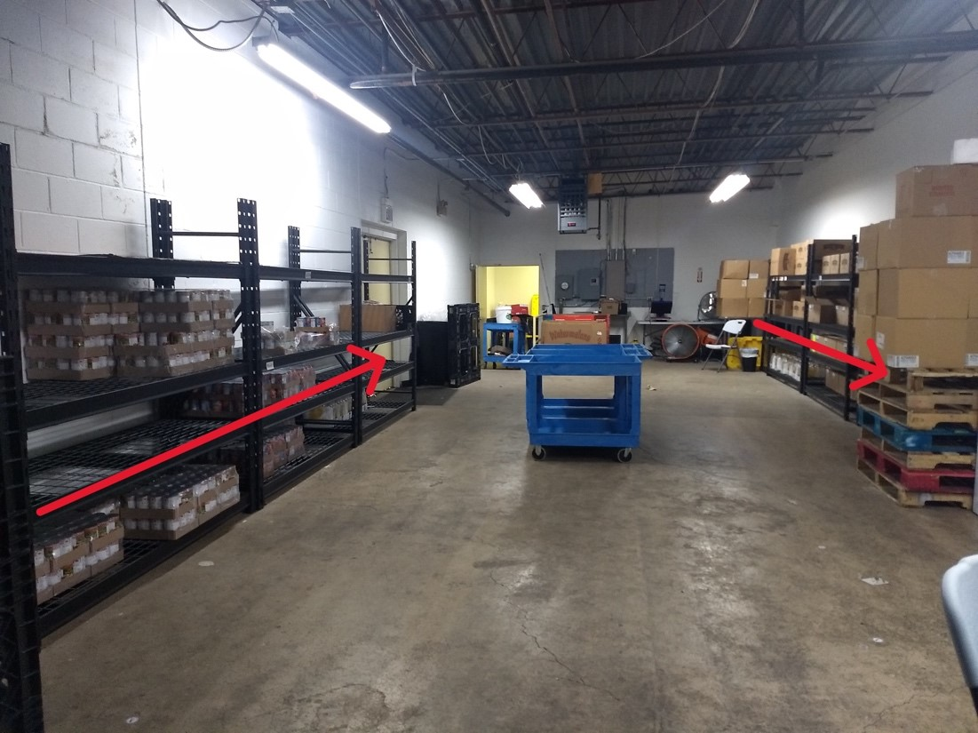
Step 3: Once all items are in, wheel cart next to the shelves. Place bags on any open shelf. Usually, five to six will fit side by side and they can be placed two deep.
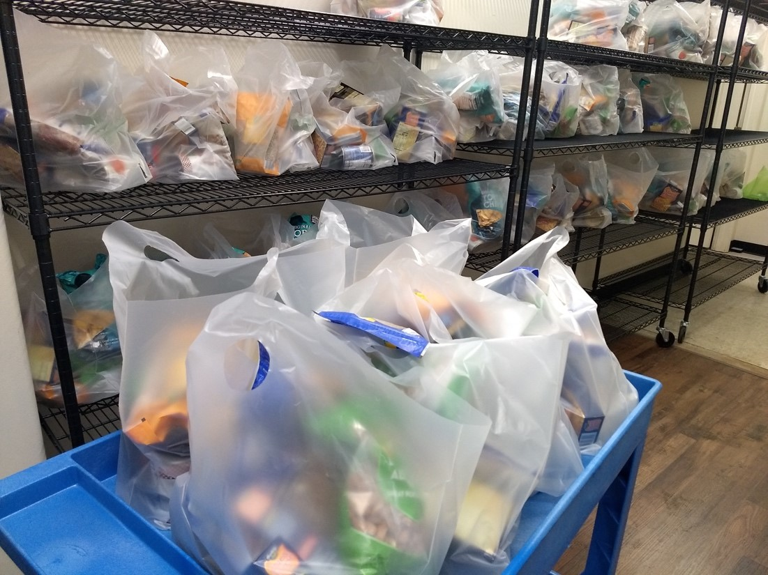
Please break down boxes and place in the large container. Plastics go in the trash can near the door to outside. Broken down boxes can also be taken outside to the dumpster. This does not have to be done to completion, but it is helpful to have at least most of it done.
Other notes:
- Please take breaks and take care of yourself! There are drinks and snacks available. These are located in the meeting room – drinks in the fridge, snacks on the counter.
- You are welcome to bring a speaker to play music.
- There are large fans in the food storage area – feel free to turn these on. There is a low setting and a high setting.
____________________________________________________________________________________

Food Pantry Sunday
What: On Food Pantry Sunday, we serve community members by giving out food, pet food, and personal care items through the Food Pantry, Pet Food Pantry, and Personal Care Items programs. Because we have volunteers putting bags together ahead of time, we are able to have short to no wait times. This is unlike many food pantries where wait times can be multiple hours long. We serve around 85-90 families a week, which translates to around 250-300 people.
Food Pantry Sunday hours are regularly scheduled on Sundays 9:30AM-12PM and 1:30-4PM for volunteers. Check the Point app for events and to sign up! We meet at Have A Gay Day (1902 Needmore Rd, Dayton, Ohio).
What we do on Sundays:
- Food Pantry Prep
- Personal care prep
- Pet food prep
- Checking clients in
- Pantry Programs (food, pet food, personal care)
- Doordash deliveries
- Van deliveries

  - Food Pantry Prep:
Shelf stable food bags: We try to get these bags made ahead of time on the Food Pantry Prep Days, but with so many clients it is necessary to make a few more on Sundays. Please refer to Food Pantry Prep Days guidelines.
Cold bags: The items in these bags are perishables, either refrigerated or frozen items. What we receive varies and can sometimes be quite random. Items that we may or may not have in stock include cheese, milk, eggs, and various types of frozen meat. The frozen Miami Valley meals are also included in these bags. Following are the guidelines for amount:
Cheese – 1 of each variety (2 max) per household
Milk – 1 jug per household
Eggs – 1 carton per household
Meat – 2-4 items per household. There is also varying size of items – if there are very large items, we try to give those out to larger households. Items have included hot dogs, pulled pork, sausage, 1 lb. ground beef, bacon, burger patties, chicken.
Miami Valley Meals – 1 per person in household. For larger households, there may be larger pans available (1 larger pan per household).
Other cold items – occasionally we receive other items such as frozen fruit, oven-bake meals, and vegetarian "meat".
Always give the full amount to clients – it is first come, first served. We may run out but we will give the full amount until we do.

  - Personal care prep:
When we have personal care items available, we give them out to those who would like them. Each household receives one personal care bag. Items that have been available include soap, shampoo, conditioner, pads, tampons, combs, nail clippers, hand sanitizer, deodorant, toothbrushes, and toothpaste. We run out very quickly so most items are not usually available. Occasionally, we have cleaning supplies such as laundry and dish detergent, cleaning spray, and wipes available.
In general, we place one item per bag with two exceptions: 1) in the case of travel size items – 2-4 travel size soaps, shampoos, and conditioners per bag when available; 2) Pads and tampons – generally 4-6 each per household.

  - Pet food prep:
Pet food is available first-come, first-served to anyone who expresses a need. The Pet Food Pantry is entirely donation-driven and there may be times that we will not have enough donations to meet needs. We keep track of visits to the Pet Food Pantry through PantryTrak and ask that visits occur only once per calendar month.
For canned pet food, we give out 6 items per pet with a max of 12 items per household per visit.
For other pet food, we give out 6 items per pet with a max of 12 items per household per visit.
If the pet food being given is over 2 pounds in weight only one item will be given per pet type per house.
If any treats, toys, litter, etc. are available, one item per household per visit will be given.
The pet food is located on the shelves in the meeting room and put into the small bright green bags.

  - Checking clients in:
When clients come in, we put their information in the system and log their visit. We use PantryTrak to keep track of clients. Generally, clients are required to show drivers license and a utility bill for proof of address.
Whether a new or existing client, we search for their name in the system. If their name is not in the system, we create a new registration, putting in name, address, age/DOB/placeholder, gender, and household size. If an existing client, we check that they are at the same address and have the same household size, and update if not. Clients are allowed to visit once a month. Currently, we do have emergency bags that we can give if they have already visited during the calendar month.
We ask to see drivers license and a utility bill for proof of address, but will work with clients who cannot provide them in one of two ways: 1) if they are already in the system, we can log their visit and 2) if they cannot provide the documents and are not in the system, we can potentially give them an emergency bag.
Following are the income guidelines from the Ohio Department of Jobs and Family Services:
Household Size | Yearly Income | Monthly Income | Weekly Income
1 | $27,180 | $2,265 | $523
2 | $36,620 | $3,052 | $704
3 | $46, 060 | $,3,839 | $886
4 | $55,500 | $4,625 | $1,067
5 | $64,940 | $5,412 | $1,249
6 | $74,380 | $6,199 | $1,430
7 | $83,820 | $6,985 | $1,612
8 | $93,260 | $7,772 | $1,793
9 | $102,700 | $8,559 | $1,975
For each additional household member add | $9,440 | $787 | $182

Following is the PantryTrak "add new client" screen:
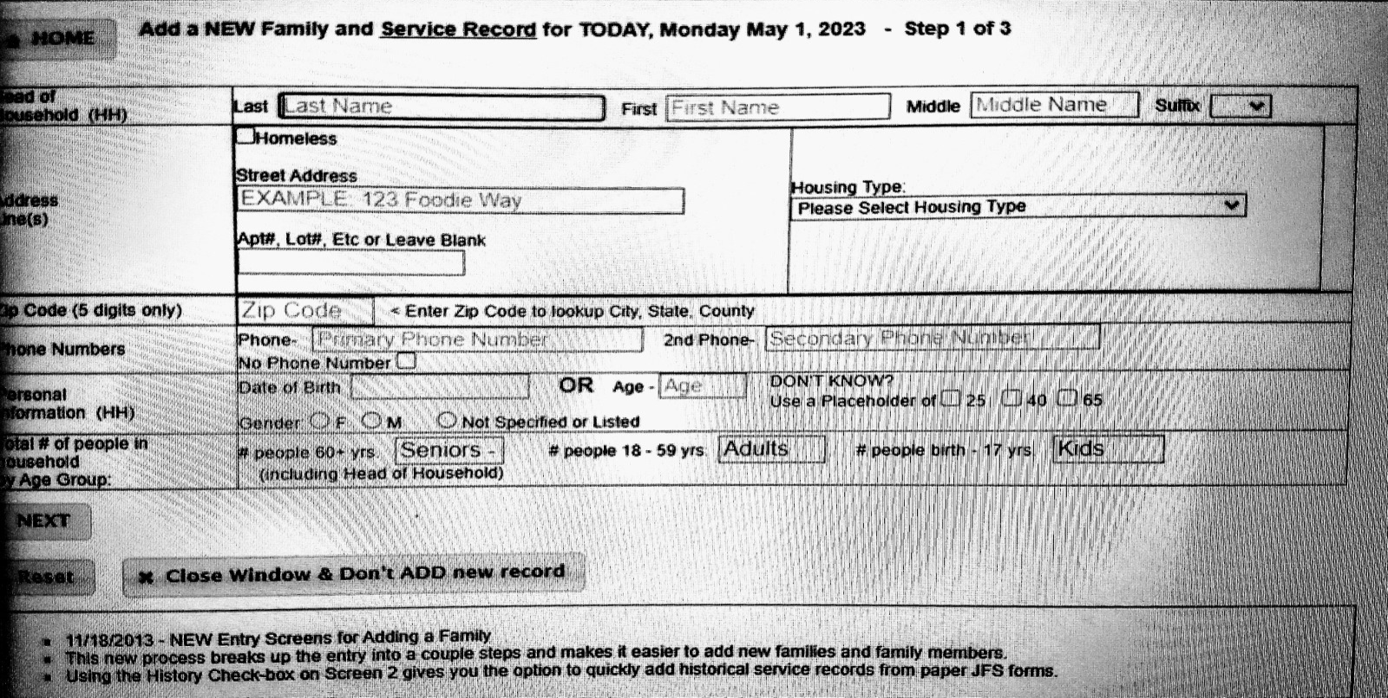
Next, on the Have A Gay Day note sheets, write client name, household size, number of pets, and if personal care is wanted. We try to remember to ask about allergies/foods not wanted – however, some families will take these items anyway for others they know who will want them.

  - Pantry Programs (food, pet food, personal care)
The number of bags given depends on household size. Each household gets one shelf stable bag per two people. A household size of 1-2 gets 1 bag, a household size of 3-4 gets 2 bags, and so on.

  - Doordash deliveries:
1. Reading entries on spreadsheet
On the spreadsheet, client's names, addresses, household size, pet info, etc. are listed. Important information to look for: household size; type and number of pets; items specially requested; items not wanted. If it says, for example, "1 pet," we do not give out pet food because we do not know what kind of pet food to give.
2. Copy info to doordash.
Copy columns E-L on the "SIGNUP LIST FOR DELIVERIES" spreadsheet into the doordash "DOORDASH UPLOAD FORM" spreadsheet columns G-N . For each bag, copy and paste once. For example, a household of one will have two entries: 1 shelf stable bag, 1 cold bag. A household of five will have four entries: 3 stable bags, 1 cold bag. After this, copy any special delivery instructions from column "M" over to column "P".
3. Printing labels.
After copying info to doordash, we edit the info on the label ("). First, type the current client's name onto the label – first name and last initial. Second, change the number of bags to reflect the number going to the client. Third, type in special instructions from columns O-T. These include: 1) Pets – [number of] cats, dogs, or No pet food available; 2) Personal care, laundry detergent, [other specially requested item], if available; 3) NO [item not wanted].
Once the information in the label is updated, print the labels. There should be one label for each bag.
4. Uploading to doordash
Once we have filled the spreadsheet (at the end of requests or what we can do at the time being), we upload the information to doordash. To do this, we download the spreadsheet as a comma separated values (.csv) document. We then open the doordash tab, upload "bulk order," and submit.
5. Placing labels on bags and adjusting items in bags.
Either now or with the help of another volunteer during the process, we place labels on the bags going out for doordash. If the label reads 3 bags/ 1 cold, there should be four labels. Three should go on shelf stable bags, and the last goes on the cold bag. Review the special instructions – items specially requested (if available) and items not wanted – and adjust bags accordingly. Make cold bags ahead of time for doordash, though labels do not need to be applied until the doordasher arrives.

  - Van deliveries:
Sometimes we get requests that are slightly outside of the doordash delivery radius. In this case, we can make the delivery to them. Volunteers will print labels, gather the bags, and use the Have a Gay Day van to deliver the bags to the client.
____________________________________________________________________________________
Miami Valley Meals pickup
Miami Valley Meals provides us with pre-made meals to help serve the community. They are cooked, packaged, frozen, and only need to be reheated to eat. We bring these meals from Miami Valley Meals back to Have A Gay Day in preparation for Food Pantry Sunday. Once arriving back at Have A Gay Day, the individual meals go in the small freezer next to the upright fridge-freezer, and larger meals in the upright freezer.
Miami Valley Meals pickup is regularly scheduled on Tuesdays at 1:00, though the time can be adjusted in advance (between 10am and 2pm M-F). We must send the forms to Miami Valley Meals two weeks in advance, so you must let us know more than two weeks in advance in order to arrange another time. We meet at Miami Valley Meals (428 S Edwin C Moses Blvd, Dayton, OH 45402) and bring the food back to Have A Gay Day (1902 Needmore Rd, Dayton, Ohio).
____________________________________________________________________________________
Thursday Food Bank Delivery
Thursday Food Bank Delivery - receive food, stock shelves, light sorting and organizing of food items in pantry.
Thursday Food Bank Delivery hours are regularly scheduled on Thursdays 9-10:30AM, except for the second Thursday of the month which varies. Check the Point app for events and to sign up! We meet at Have A Gay Day (1902 Needmore Rd, Dayton, Ohio).

Digital Team Guidelines and Instructions
Welcome! Below are a few of our rules and regulations to help you better perform the duties we ask of all our volunteers and page admins.
As an admin, you will be responsible for monitoring one or more of three separate areas of the page which we will cover within. From time to time you may have questions related to your responsibilities - please address all questions to our administrative assistant. You may contact her either through a private Facebook message or by email.
The first area you will be responsible for is checking posts to the page made by people outside of the organization. The things we are checking for are pornography and hate speech. We have a zero-tolerance policy when it comes to these and you will have the ability to remove these posts and ban the users who have posted it. We define hate speech as "any negative or demeaning comments that attempt to devalue a person's life including comments about sex, national heritage, sexual orientation, gender identity, political affiliation, socioeconomic status, or religious belief."
The second area is checking through the comments made by our followers on the posts we make. Again you will be checking for hate speech and porn.
The third and possibly most crucial part of being an admin is answering messages Facebook users have sent to the page. We get quite a few messages every day but we have dedicated admins (just like you) who help us connect with the people reaching out to us. On the following page are the procedures and answers to several of the usual questions first time admins have.
From the bottom of our hears, we here at Have A Gay Day would like to thank you in advance for all of the support. Without you we wouldn't be where we are today.

Overview
All Digital Team Volunteers must be 18 years old as some conversations may not be appropriate, and some items that are shared with us may be graphic in nature. While we do our best to moderate, we also recognize that the safety of our volunteers and a safe environment for all ages is not always possible.
All volunteers must complete a volunteer application for the Digital Team before starting on assignment. This volunteer application will be digital and will help the Volunteer Coordinator. If you have any questions, please check in with any admins.
Volunteers may be asked to complete additional virtual or in person training when available. If a volunteer has additional skill sets please make us aware of these or any additional training you may receive while volunteering with us that could expand your role.
We are always learning and growing. Please give feedback whenever possible and take time to grow with us and help us by updating and all information that we have. Your support helps us to be better and that is our goal: improvement for the community.
____________________________________________________________________________________
What does being a moderator mean?
We want you to fully understand what you're signing up for and what it means to moderate for us or to answer messages for us. We take our community seriously and want to make sure that you always remember the importance of this volunteer position. We have a lot of people that reach out, comment, and message us every day. When someone sees or interacts with us, they interact with you.
Time Commitment:
We ask that if you're moderating, answering messages, approving group members in our group, etc., that you set aside regular time in your schedule to do so. There is no set amount of time you must spend each week, but we ask that you consistently complete tasks for three weeks. Then, please take one week off for your own mental health. The time commitments and the number of interactions that you will have require recovery time.
Digital Team Chat:
We have a group chat specifically for members of the Digital Team. We will communicate changes, general check-ins, and introductions between volunteers through the chat. If there are questions that you don't know how to answer, you can ask the group. This might include questions about comments on the front page, posts, or private messages we receive.
Knowledge Base (Online Moderator Resource Guide):
Have A Gay Day, the volunteers, the staff, and the leadership will provide a virtual knowledge base that can be used when answering questions in the inbox or on the page. This information will be developed and updated and we also have the expectations that this information will be used when responding to messages as needed. Some of the information may sound generic but all of the information provided will be current for the organization.
Crisis messages or posts:
From time to time you may happen on a crisis situation. A note, a comment, a life altering decision that is being shared with Have A Gay Day. If you are not trained in handling a crisis situation, please immediately refer to the Digital Team Group or the leadership of Have A Gay Day. There will be positions within the volunteer Digital Team Group that will be receiving training to handle these moments. We ask that you hand these off to one of them immediately.

Digital Team Breakdown
Admins: responsible for all aspects of all platforms. An admins may move from one digital platform to another to create content, talk to someone about a situation, or speak for the organization when it is necessary. An admin will spend 3-5 hours a week in a combined effort for all admin roles they are working in. There may be specific admins that are serving as guests in those positions to observe as Board Roles within the organization. Also, some admins may be specific for a group or specific social media channel.
Content creators: may post across social media channels as Have A Gay Day. All items posted must not be for personal financial gain, must be neutral in all ways – no conflict of interest, and can't be political in any way or manner. Content creators may also create memes, locate news articles, and create interactions on our media channels. When in doubt, please check in with Team Leads and Admins. Also, please fact check, credit artists, and never post statements that may not be aligned with Have A Gay Day's beliefs and mission.
Digital Team Leads: serve as the go-to volunteers. This position is a trusted position for making judgment calls and for being dedicated to spending time and knowing a bit more about Have A gay Day's inner workings. These team members should have a good working knowledge about Have A Gay Day and also be well-versed across the digital platforms with access to handle situations that may require special access to different platforms.
Crisis Leads: have had additional crisis training and are set in place when a volunteer is not sure of a situation or would like another perspective. This is not a professional coming in, but someone with additional peer-to-peer training. When handling a crisis situation, do not sign your name when replying. This allows multiple people to answer a situation and the conversation becomes more fluid.
Group Moderators: manage the Meta group of Have A Gay Day They check requirements for joining the group. They also follow the layout of approval or denial of posts. They moderate comments and make judgement calls about content and follow up comments as well.
Front of page Moderators: spend time going through comments, visitor posts, and reviews on the posts of any digital platform. A moderator may choose to hide, delete, or ban as they see fit; make sure that threads are followed up on to eliminate misunderstandings; etc. Also, make sure to view the comment section in multiple ways. For example, on Meta, you can view all comments, view hidden comments, view newest comments, view oldest comments. Some comments won't pass the vibe check and when that happens, you make the call to keep or end the person's membership with the digital platform. If you ever have any questions are aren't quite sure what to do, feel free to screenshot and ask the Digital Team Group for their thoughts. Please remember to never repost or share any comments, posts, etc. unless you are required for safety or an emergency situation.
Inbox Moderator: spends time replying to messages sent to the page. This may potentially be the most stressful volunteer position on any given day. We recommend that you take time with replying, with moving from message to message, and we encourage you to always find support answering messages. If you don't know, check reference material and check in with other volunteers that are on the inbox. There may never be a perfect answer for everything, but giving an answer makes all the difference. Also, please be mindful that some messaging us are international and in different countries, so different laws apply. Be patient, be kind.

The Digital Team Rules
1) When commenting as Have A Gay Day or replying to a message, you must sign your name. This can be a real name or name you have created, as long as it's professional and as long as we know the handle you're using. Normally we reply to messages and simply sign with a dash - and our first name. The only time that we may not sign is during a crisis situation in the inbox. When there is a crisis message we do not sign since multiple volunteers may be responding to the same person.
2) We do not suggest that anyone "comes out" if they are not in a safe situation. Considering we speak with people from all over the world, coming out can be a death sentence depending on where people are living. We never know the full situation, but Have A Gay Day does not encourage coming out unless we know the details, know the person will be safe, and always promote that the person comes out when it's right for them. Imagine telling someone to come out no matter what and then a few days later finding out the person was harmed in some way or kicked out based on our advice to them. That is not something we ever want to see happen.
3) We do not send friend requests to people that we are interacting with as Have A Gay Day. No matter the social media platform we are using, we don't share our personal information with who we are talking to or who we see interacting with Have A Gay Day or its community. There may be moments of crisis where we do have to add someone, and moments that we may look at someone's profile to find family members or friends in direct crisis situations, but we never leave our scope as Have A Gay Day moderators to follow or friend our community that interacts with Have A Gay Day. This is for multiple reasons but we maintain professionalism and security by doing this.
4) The information that you receive as a moderator for Have A Gay Day is not to be shared unless it is a potential crisis or information that is required legally to be shared. Members of the community may open up about all kinds of personal issues and life moments. While at times you may want to help outside the scope of volunteering and step into someone's life to intercede or even share information, you must understand that messages sent to us privately are meant to be private. Also, keep in mind that the members of the community put trust in us to answer their questions without others knowing they are asking them. Sharing the information we receive potentially creates more harm for the individual and the organization and thus shouldn't be done. If you ever feel there is information that needs to be shared, such as clear threats and crisis, please connect with other members of the digital team and leadership.
5) There may be times that your personal opinion does not align with the belief or the stance of the organization. Someone may ask a question that you feel strongly about and before you respond we must ask - is what the organization would say to the person? When it comes to faith, politics, war, social issues, or anything else, when you respond to someone you are responding as Have A Gay Day. Please always keep this in mind. We are held responsible for how you reply to someone in messages, on the front of our social media channels, and all other interactions. If your response or action appears to represent Have A Gay Day, the way that it is perceived matters.
6) "Someone else will do it or get to it" should never be a thought. As a volunteer of Have A Gay Day on our digital platforms, one minute that hate is allowed to stay up is too long. One message that is in crisis that sits for an hour could be the difference between saving a life and losing a life. It is a huge responsibility and it can be stressful, but the importance of each message and comment is critical to understanding the value that each person has that interacts with us. If a message is left because you don't know how to respond or a message is starred awaiting a response, please reach out if no one has responded after 24-48 hours. Based on the urgency, possibly reach out sooner and faster. We don't want our community being left on "read." While we will always have some moments of pause, a waiting period for a better answer, or waiting on someone that is specialized, we must always understand that we all represent Have A Gay Day.
7) You will be volunteering with a diverse moderator team and the same kindness and compassion that you show for the community we expect to be shown for each of our volunteers. Some volunteers may send you friend requests and chat with you about different things in their daily lives and some may become life-long friends. We ask that you set your boundaries and privacy, as far as allowing people to add you or befriend you.
As an organization we can't tell you what you can or can't do when it comes to friendships, but we can ask that the friendships you maintain outside of Have A Gay Day are left outside the scope of your volunteerism when it comes to decision making. Such as, if your friend messages the page and tells Have A Gay Day they are going through a crisis and tells you personal info, you should not message the person and let them know that you know. If someone is asking to share a fundraiser and you know them and want to help, it doesn't mean you share their fundraiser or do anything that would be considered special treatment or outside of the scope of how you interact with all other members of the Community. This also comes to moments that may be seen as drama or spill-over from personal lives to the organization.
While it is perfectly fine to maintain friendships on our team, if something ever doesn't go as planned, please remember to keep things separate emotionally and behaviorally. For example, a moderator may be experiencing a crisis, and you financially assist or come through for them. Perhaps they don't make the best decisions in your opinion with the help you have provided. Any ill feelings or potential drama needs to be kept on a personal level and not an organizational level. If at any time we feel there is an issue, we may address it privately. We ask that you as a volunteer maintain kindness to our online community and volunteers.
8) Your assignment as a volunteer lasts for three weeks. After the three weeks, we request that you take a week away or a week off to re-focus, collect your thoughts, and take some personal time for yourself. After your week away, we ask that you re-read all written materials for the digital team. We ask this because there are always going to be changes and updates and there will be things you will forget that are good to review. The review of information will be critical to your volunteerism with the organization. As we grow, change, and learn, our information will also continually be improving. There will always be new things and improvements and the community that you are volunteering with deserves to have you informed and up to date. After your week away and a personal review of the info, you may start another three-week assignment. You may also choose different digital team positions or focused areas but please interact with the Digital Team Leads or Admins before shifting focus if you have never volunteered in these areas before.
9) Remaining active as a digital volunteer also means that you interact with the posts in the social media groups that are designed for volunteers. This could include a comment, a reaction, or making a post-sharing content within the group. If you are unable to do so, feel free to e-mail or message Digital Team Leads or admins and check in from time to time. You will also be able to use the Point Volunteer App to check in and view reminders for upcoming meetups and events. If you are not active or plan not to be active for 30 days or more, please tell us of this. Also, you are more than welcome to leave or start an assignment at any time – just let us know if you will be away for an extended period.
10) We all have different understandings and different ways of doing things. Please respect each other in the highest regard. We should never discredit others' thoughts, opinions, and life experiences because of our own life experiences. Just because you have worked as a writer for ten years and may have knowledge about it, someone else you are interacting with as a volunteer or community member shouldn't be discredited or dismissed because you personally feel you are an expert or have a deeper knowledge. Also, please understand that as a volunteer, you will encounter many walks of life and many people from all around the world. The world is diverse. Your kindness and grace for humanity should be too.

